Test Scenarios for **Afternoon Person, Potential Loan**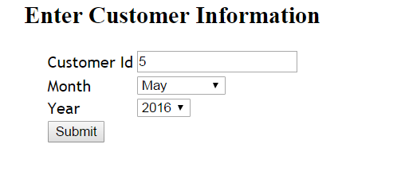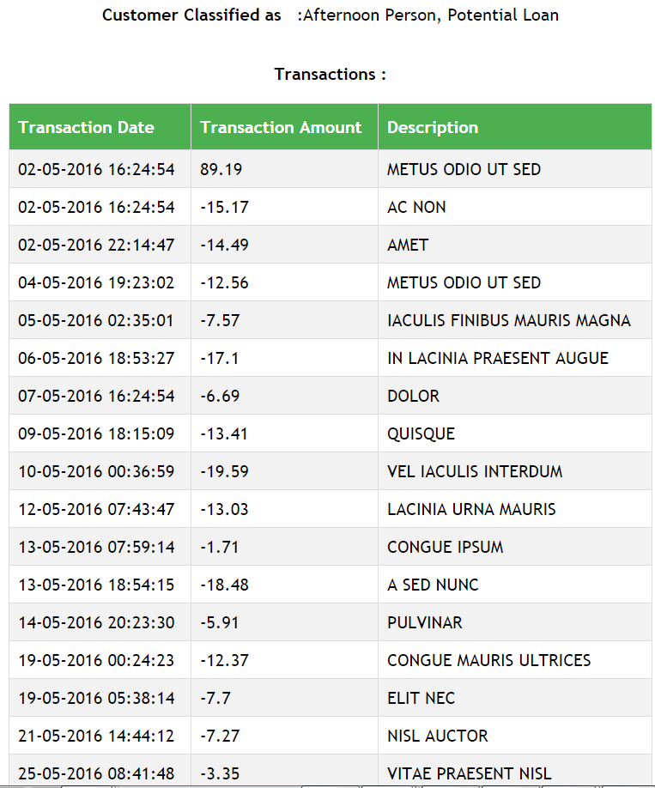

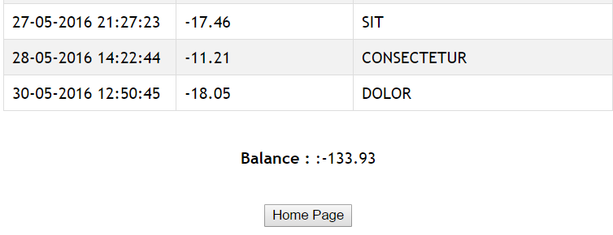

**Here is the data for above scenario**

|  |  |  |  |
| --- | --- | --- | --- |
| CustomerId | Date | Amount | Description |
| 5 | 5/05/2016 2:35:01 AM | -7.57 | IACULIS FINIBUS MAURIS MAGNA |
| 5 | 2/05/2016 4:24:54 PM | 89.19 | METUS ODIO UT SED |
| 5 | 12/05/2016 7:43:47 AM | -13.03 | LACINIA URNA MAURIS |
| 5 | 7/05/2016 4:24:54 PM | -6.69 | DOLOR |
| 5 | 30/05/2016 12:50:45 PM | -18.05 | DOLOR |
| 5 | 9/05/2016 6:15:09 PM | -13.41 | QUISQUE |
| 5 | 28/05/2016 2:22:44 PM | -11.21 | CONSECTETUR |
| 5 | 2/05/2016 10:14:47 PM | -14.49 | AMET |
| 5 | 25/05/2016 8:41:48 AM | -3.35 | VITAE PRAESENT NISL |
| 5 | 14/05/2016 8:23:30 PM | -5.91 | PULVINAR |
| 5 | 6/05/2016 6:53:27 PM | -17.1 | IN LACINIA PRAESENT AUGUE |
| 5 | 13/05/2016 6:54:15 PM | -18.48 | A SED NUNC |
| 5 | 27/05/2016 9:27:23 PM | -17.46 | SIT |
| 5 | 21/05/2016 2:44:12 PM | -7.27 | NISL AUCTOR |
| 5 | 4/05/2016 7:23:02 PM | -12.56 | METUS ODIO UT SED |
| 5 | 19/05/2016 5:38:14 AM | -7.7 | ELIT NEC |
| 5 | 2/05/2016 4:24:54 PM | -15.17 | AC NON |
| 5 | 13/05/2016 7:59:14 AM | -1.71 | CONGUE IPSUM |
| 5 | 10/05/2016 12:36:59 AM | -19.59 | VEL IACULIS INTERDUM |
| 5 | 19/05/2016 12:24:23 AM | -12.37 | CONGUE MAURIS ULTRICES |